HOSPITAL:

Respiratory Care Services Policy and Procedure Manual

Policy and Procedure | StabilTube™
Area: Respiratory Care Services | Performed by: Respiratory Care Practitioners
Policy Number: | Approved by:
 | Date:
Current Effective Date | Approved by:
 | Date:
Review Date | Approved by:
 | Date:
Revised Date | Approved by:
 | Date:

POLICY
This policy assures the standardized of use of the StabilTube™ Long Term Endotracheal Tube Holder for securing the endotracheal tube in the pediatric, adolescent and adult patient.

PURPOSE
The purpose is to provide an easy implemented protocol to be used by the Respiratory Care Practitioner with effective guidelines and consistent instruction for use and application of the StabilTube™ for securing the endotracheal tube.

DEFINITION
To ensure patient safety, the patient with a temporary, artificial translaryngeal airway should have the fixation device secured at the earliest appropriate time.

SETTINGS
The endotracheal tube should be placed and secured in an environment in which the patient can be physiologically monitored and in which emergency equipment and appropriately trained health care providers with airway management skills are immediately available.

EQUIPMENT
B&B StabilTubeTM (includes StabilTube Endotracheal Tube Holder, Skin-Prep™, Releasable Cable Tie and Blue Tie Cap), Alcohol Swabs, Bandage Scissors, Skin and Oral Care Supplies, Suction setup with an appropriate size catheter and an oral suction attachment. Use of the B&B Universal Bite Block™ or the B&B Bite Proof Bite Block™ is recommended with the StabilTube.
.
Skin Prep™ is a registered trademark of Smith & Nephew.
VELCRO® brand is a Registered Trademark of VELCRO Industries B.V.
PROCEDURE
A: Application/Preparation Steps
1. Note endotracheal tube placement at either the nare or teeth/gum line and compare with existing charting as to proper depth. If this is a new endotracheal tube placement, auscultate to assure bilateral breath sounds and a proper reading using an ETCO₂ device. If possible, ascertain tube placement with an X-Ray prior to securing with the releasable endotracheal tube Cable Tie.
2. Clean the patient’s face to remove all secretions & moisture from the application areas. Application areas are either the area between the nose & upper lip laterally along the face to beneath the ear lobes or the area over the bridge of the nose and cheek area.
3. Clean the endotracheal tube from point of placement to its distal end to remove all moisture and secretions.
4. Wipe & clean both application areas on the face and the endotracheal tube with an alcohol prep pad and fan dry the areas.
5. Place the endotracheal tube in the appropriate position in the mouth. Positioning of the endotracheal tube must be changed in the mouth, from side to center to side every tape change to prevent tissue erosion and facilitate oral care.

B: Application/Action Steps
1. Apply a skin barrier to the area on the face in which you will apply the adhesive. Apply Skin PrepTM to both the facial skin and endotracheal tube application areas. Fan dry for at least 25 seconds.
2. The adhesive application areas include the following:
a. Oral Application securing to the Upper Lip: prep the area between the nose & upper lip laterally along the face,
b. Nasal Application, prep the area over the bridge of the nose and cheek area.
c. Endotracheal tube, prep at point of securement.
3. Place the ET Tube in the appropriate position in the mouth. Positioning is recommended to be changed in the mouth from Left of Center to Right of Center every tape change to prevent tissue erosion and to facilitate oral care.
4. Place the Cable Tie over the head of the endotracheal tube (Figure 1). Remove the release liner from the face piece and the T-Tab (Figure 2/Figure C).
5. Apply Face Piece and T-Tab (Figure 3) on the desired prepped area of the face and tube with Cable Tie (Figure B) centered over the endotracheal tube.
6. Check that the endotracheal tube is at the proper centimeter marking with the appropriate anatomical landmark. Apply adhesive back of the T-Tab to the endotracheal tube. Secure the retaining unit tight, ½ inch above the identification marking on the tube. For maximum securing ability, do not place anything between the retaining unit and the endotracheal tube.
7. Peel the remainder of the backing, and place over the lip for oral intubation, over the bridge of the nose for nasal intubation.
8. Pass the Elastic VELCRO® brand neck band (Figure 4) under the earlobe & behind the patient's head, around the neck, and by the other earlobe. Take the VELCRO® brand leading edge of the Neck band and pass it through the Buckle D-Ring and fasten (Figure 5). Be sure to pull the neck band snug so that only one finger can be inserted between the neck band and the patient's neck.
9. Smooth the VELCRO® brand section to assure maximal engagement of the VELCRO® brand with the neck band material.
10. Firmly apply pressure with a smoothing action to ALL adhesive areas that have contact with skin.
11. After the endotracheal tube position is confirmed, trim off the excess Cable Tie tab beyond 1/2 inch above the retaining unit (Figure 6). Place the Blue Cap on the cut end of the Cable Tie.
12. Periodically inspect the device for proper adhesion and the Cable Tie for secure retention.
13. To release the Cable Tie, grasp the head of the Cable Tie and the ET Tube and remove the Blue Cap. Deflect the release and push the excess tab through the cable port.
.

C: Documentation
Chart the Time, Date, endotracheal tube size and cm marking at the appropriate anatomical landmarks on the hospital documentation Flow Sheet.

D. Adjusting, Changing &/or Removal of StabilTubeTM
1. To adjust the depth of the endotracheal tube, release the Cable Tie around the endotracheal tube. Firmly hold the endotracheal tube once the Cable Tie is loosened to prevent accidental extubation. Adjust the position of the endotracheal tube, confirm position and re-secure the Cable Tie around the endotracheal tube.
2. To adjust the tightness of the neck band, or to provide skin care, release the VELCRO section of the neck band & adjust to appropriate tightness. To completely remove pass the VELCRO tip through the Buckle.
3. To remove the StabilTubeTM, release and completely open the Cable Tie from the endotracheal tube. Firmly hold the endotracheal tube once the Cable Tie is loosened to prevent accidental extubation.
4. Wash and provide the patient's face and neck with the appropriate skin care.

F: Precautions/Adverse Effects
1. Possible Adverse effects are tube slippage and possible inadvertent extubation.
2. Periodically inspect the StabilTube and patient Q-shift, prn or more frequently. In the event the patient is diaphoretic, has copious oral secretions, loss of adhesion on the patient’s face or endotracheal tube may occur, immediately replace the StabilTube. A spare is recommended at the bedside.
3. Periodically inspect the space between the neck band of the tape and the patient's neck. It should be snug enough to only allow one finger to be inserted. If it is too tight or too loose, adjust the neck band immediately.
4. Periodically inspect the skin area under the adhesive backing to help prevent injury to the lips and underlying tissues due to unrelieved pressure.
5. Never use Benzoin or other adhesive enhancing product in conjunction with this or any other Acrylic Hypo-Allergenic Adhesive product. Always use the Skin barrier provided.
6. After providing skin care, make sure the adhesive contact areas are completely dry and not oily.
7. The StabilTube should not be used by persons shown to be allergic to the adhesive.
8. Do not wrap the Pilot Balloon Tube in the loop with the Cable Tie.
9. Do not pull the Cable Tie tight with any other device except two fingers. If pulled too tight the endotracheal tube may hourglass and alter the inner diameter of the endotracheal tube. This can be noted by a significant dip in the endotracheal tube surface on either side of the Cable Tie.
10. Support the ventilator tubing to reduce pressure on the endotracheal tube.
11. The StabilTube is intended for single patient use.

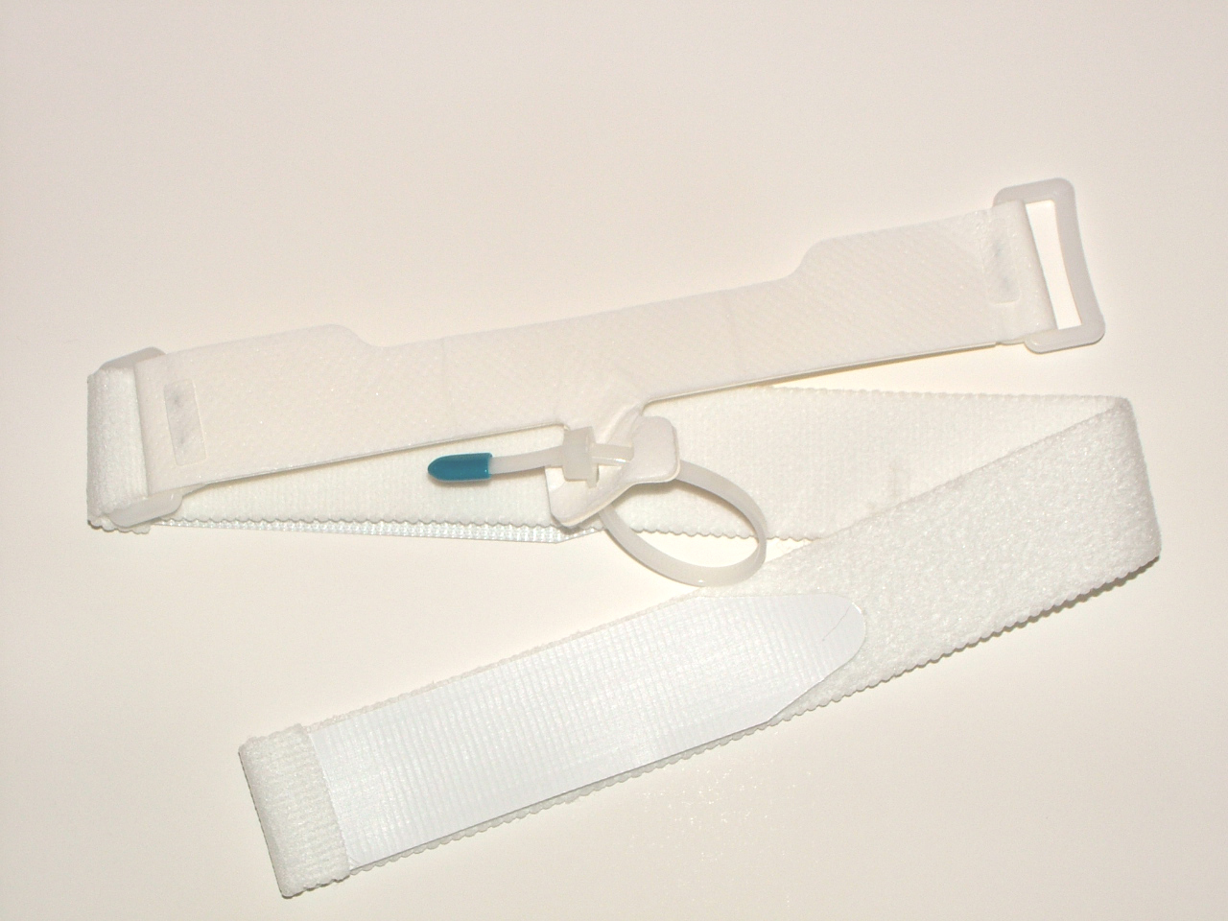
Buckle D- Ring
Cable Tie
Face Piece
T-Tab

Figure A

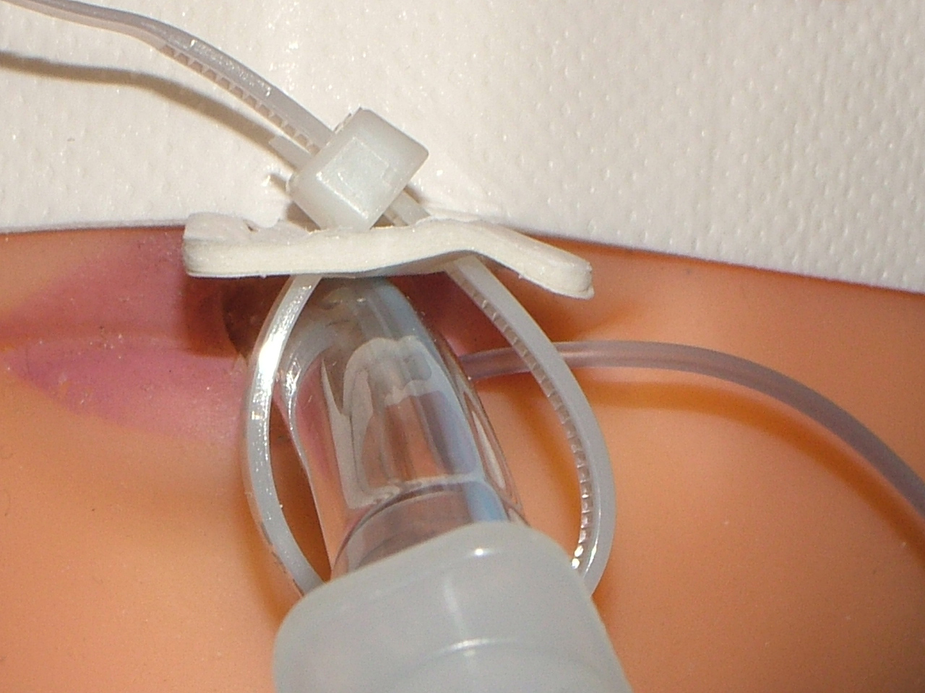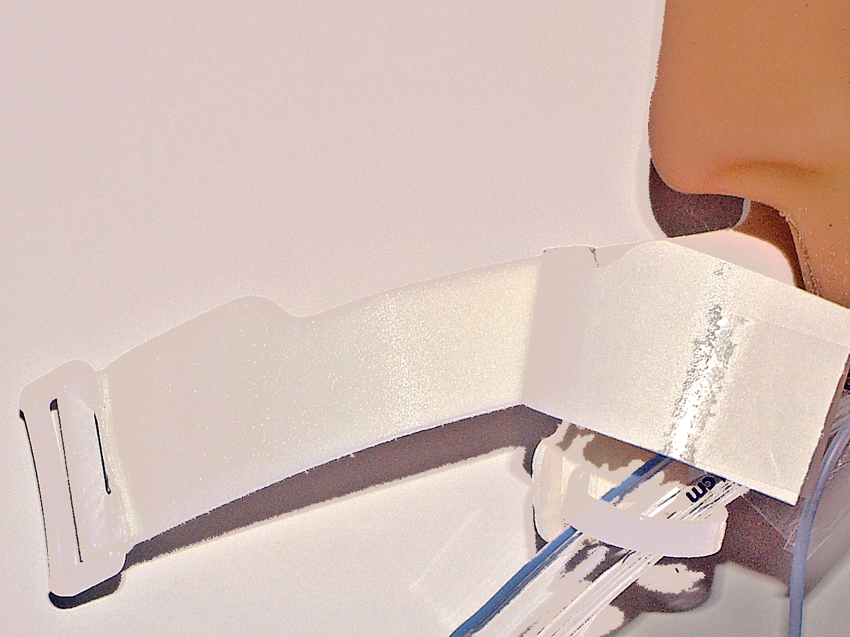
Release Liner

Figure B Figure C

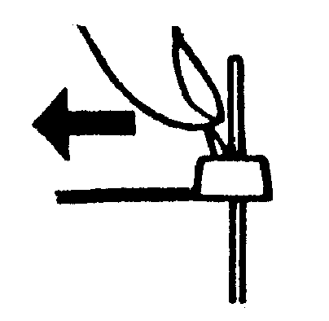
Releasable Cable Tie
Figure D

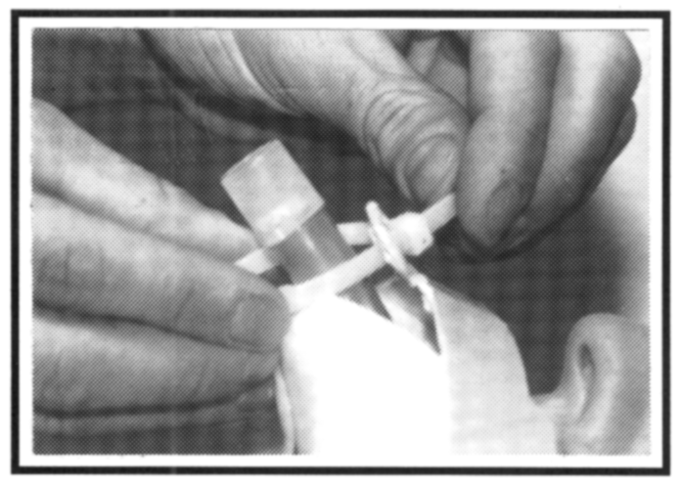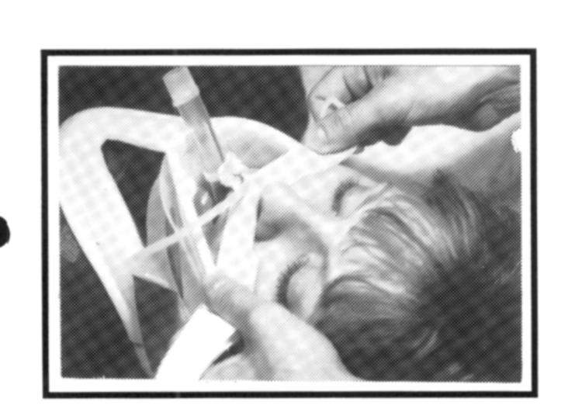
Figure 1 Figure 2

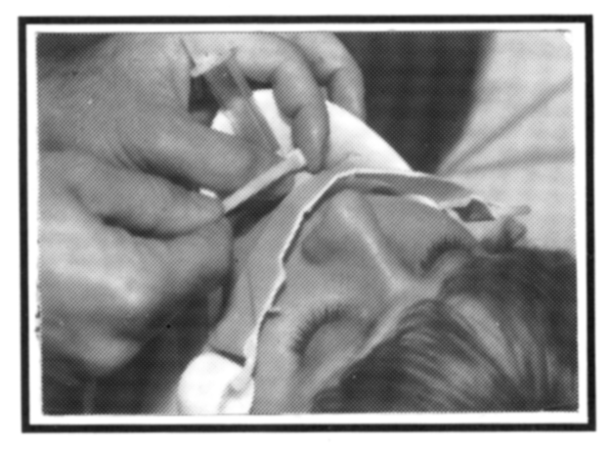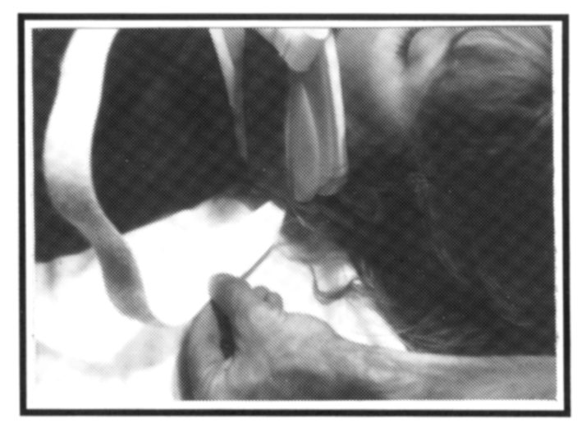
Figure 3 Figure 4

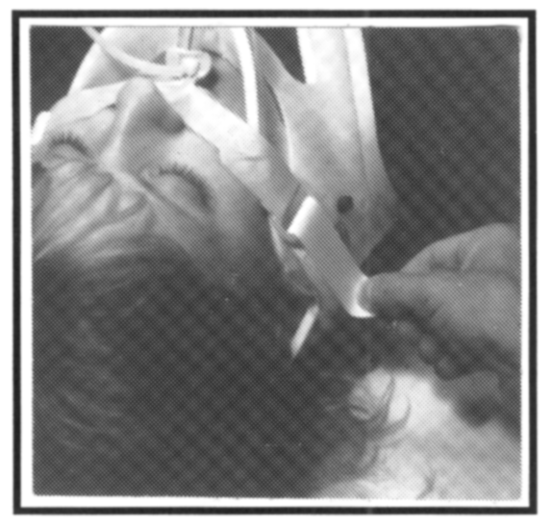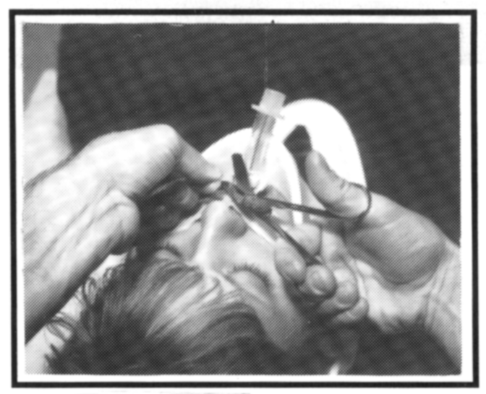
Figure 5 Figure 6

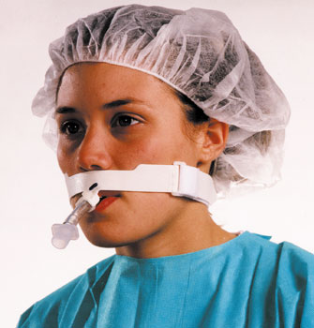
REFERENCES
1. AARC Clinical Practice Guideline/Management of Airway Emergencies
Respir Care 1995; 40(7):749-760)
2. AARC Clinical Practice Guideline/Removal of the Endotracheal Tube
Respir Care 1999; 44(1):85-90)
3. 2005 American Heart Association Guidelines for Cardiopulmonary Resuscitation and Emergency Cardiovascular Care. Part 7.1: Adjuncts for Airway Control and Ventilation. Circulation 2005; 112: IV-51-IV-57.

